INFS3208 (Cloud Computing) - Possible Exam Question Study Notes

Multiple Choice· New here.. Wanna ask what is this doc for?
What are the business drivers for Cloud Computing?
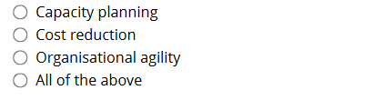
Answer: D - All of the above

Which of the following is NOT regarded as an IT resource in Cloud Computing?
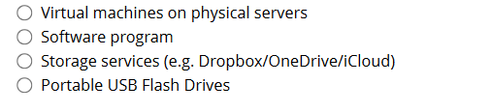
Ans: D - Portable USB Flash Drives
What is a public cloud?
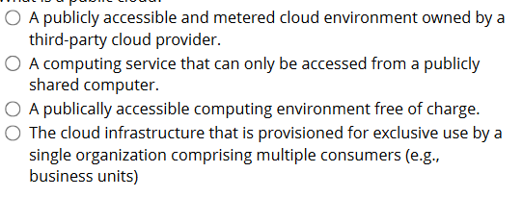
Ans: A - A publicly accessible and metered cloud environment owned by a third-party cloud provider
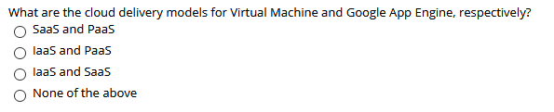
Ans: B - IaaS and PaaS
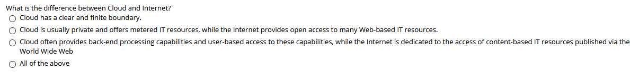
Ans: D - All of the above
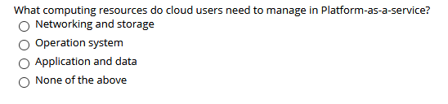
Ans: C - Application and data
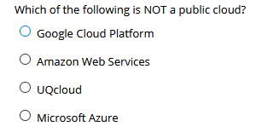
Ans: C - UQCloud

Which of the following statements about Virtual Private Cloud (VPC) is NOT correct?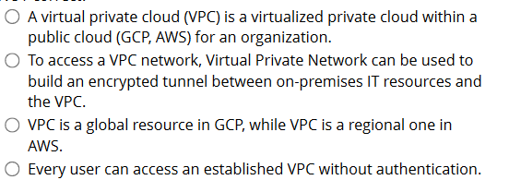
Ans: D - Every user need authentication to access an established VPC

Which of the following statements about the VPC's firewall is NOT correct?
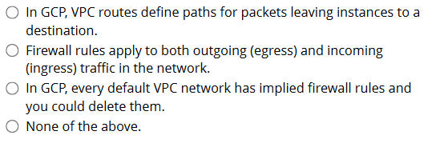
Ans: C - In GCP, every default VPC network has implied firewall rules and you could delete them (you cannot delete them)
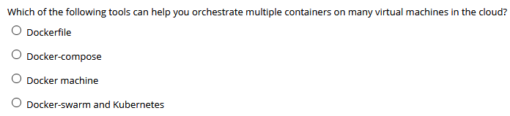
Ans: D - Docker-swarm and Kubernetes

Which of the following commands can be used to replace docker compose up?
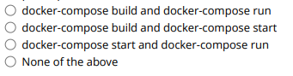
Ans: A - docker-compose build and docker-compose run
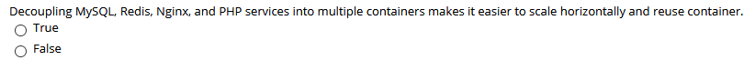
Ans: A - True
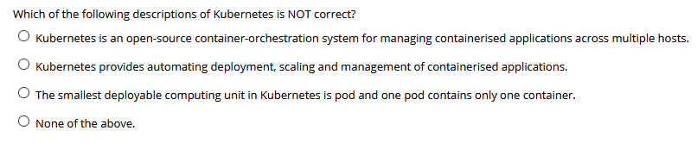
Ans C - The smallest deployable computing unit in Kubernetes is pod and one pod contains only one container (It can contain multiple)

Which of the following must all the communications between components go through?
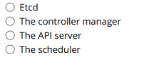
Ans: C - The API server

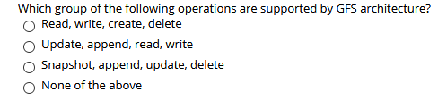
Ans: A - Read, Write, Create, Delete
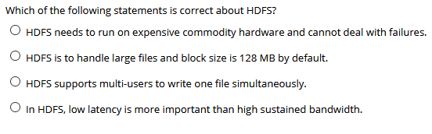
Ans: B - HDFS is able to handle large files and block size is 128 MB by default
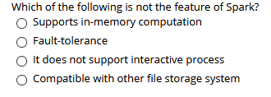
Ans: C - Spark does support interactive process
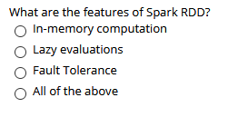
Ans: D - All of the above
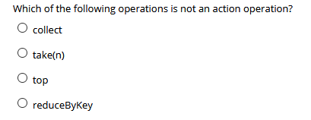
Ans: D - reduceByKaey
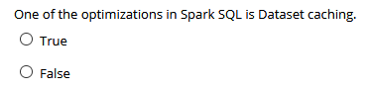
Ans: A - True
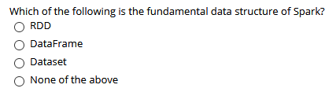
Ans: A - RDD
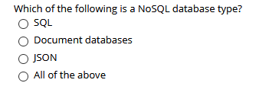
Ans: B - Document databases
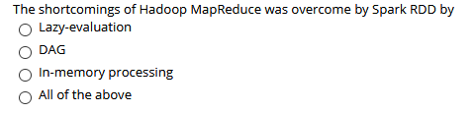
Ans: D - All of the above
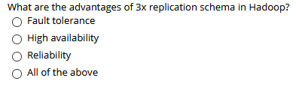
Ans: D - All of the above
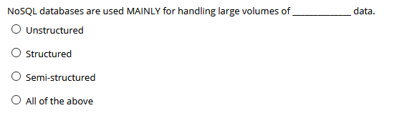
Ans: A - Unstructured

________ stores are used to store information about networks, such as social connections.
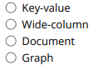
Ans: D - Graph
Which of the following belongs to the Cluster File System?
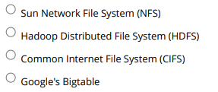
Ans: B - HDFS
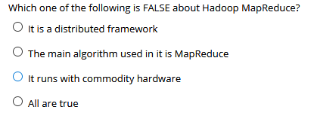
Ans: D - All are true
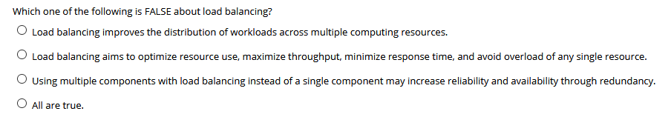
Ans: D - All are true
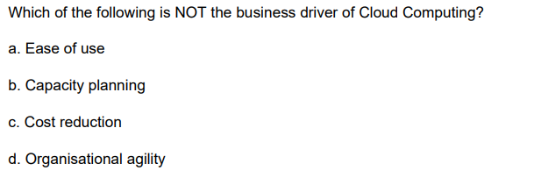
Ans: A - Ease of use
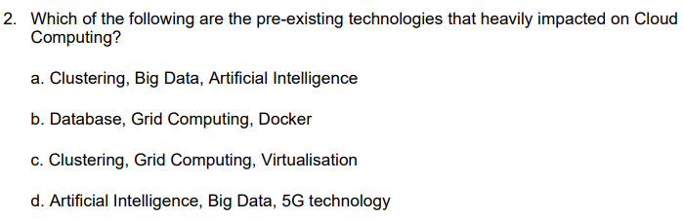
Ans: C - Clustering, Grid Computing, Virtualisation
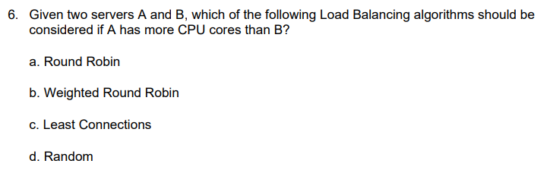
Ans: B - Weighted Round Robin
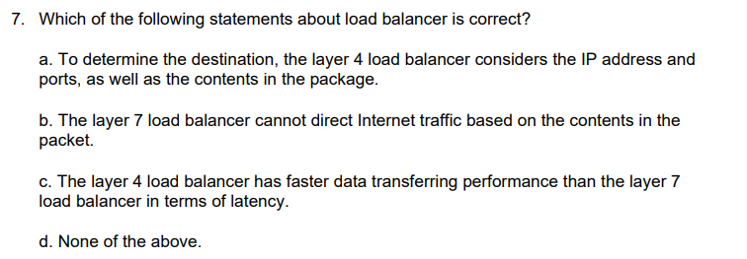
Ans: C - The layer 4 load balancer has faster data transferring performance than the layer 7 in terms of latency

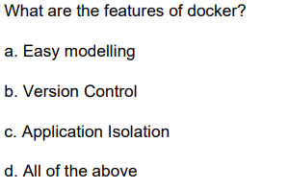
Ans: D - All of the above
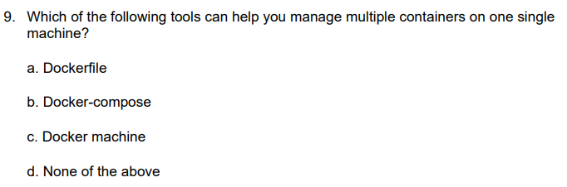
Ans: B - Docker-compose
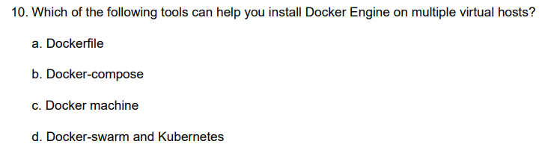
Ans: C - Docker machine
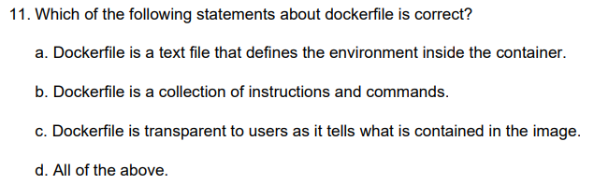
Ans: D - All of the above
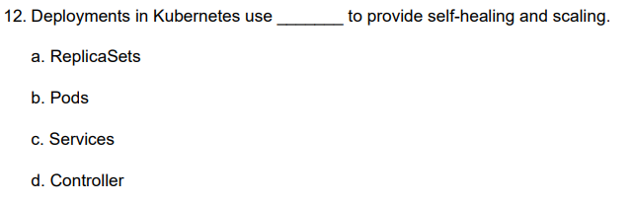
Ans: A - ReplicaSets
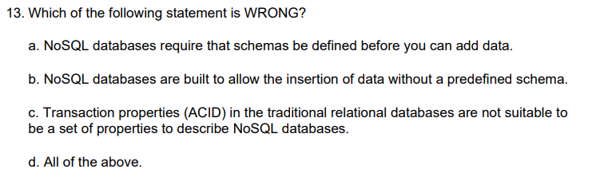
Ans: A - NoSQL database require that schemas be defined before you can add data
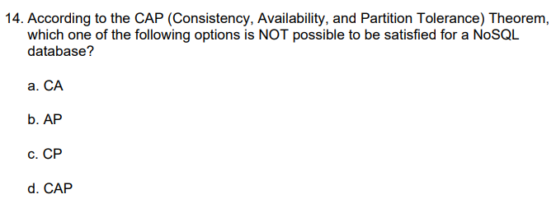
Ans: D - CAP
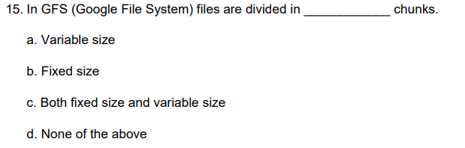
Ans: B - Fixed size
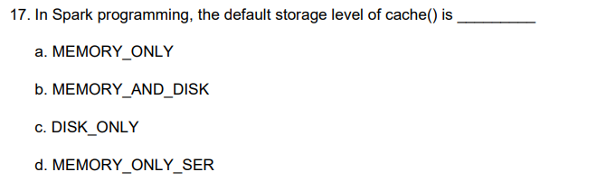
Ans: A - MEMORY_ONLY
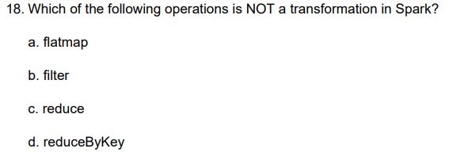
Ans: C - reduce
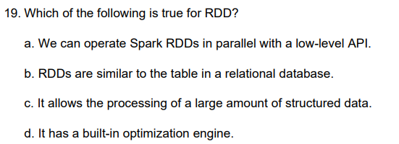
Ans: A - We can operate Spark RDDs in parallel with a low-level API
Which of the following statements about Asymmetric Encryption is correct?
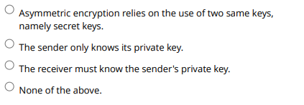
Ans: D - None of the above

Short Response Questions

Ques - Kubernetes workflow
1. User via "kubectl" deploys a new application. Kubectl sends the request to the API Server.
2. API server receives the request and stores it in the data store (etcd). Once the request is written to data store, the API server is done with the request.
3. Watchers detects the resource changes and send a notification to controller to act upon it
4. Controller detects the new app and creates new pods to match the desired number of instances. Any changes to the stored model will be picked up to create or delete Pods.
5. Scheduler assigns new pods to a Node based on a criteria. Scheduler makes decisions to run Pods on specific Nodes in the cluster.
6. Kubelet on a node detects a pod with an assignment to itself, and deploys the requested containers via the container runtime (e.g. Docker).
7. Kubeproxy manages network traffic for the pods - including service discovery and load-balancing. Kubeproxy is responsible for communication between Pods that want to interact.

Q25) What is the lazy evaluation mechanism in Apache Spark?
1. Transformations in Spark RDDs are evaluated or computed in a lazy manner: which means it will not begin to execute until it sees an action.
2. The lazy evaluation means that when transforms on RDD are called, the operations are not immediately performed.
3. Spark internally records metadata to indicate that this operation has been requested.

4. 5. Spark uses the Lazy Evaluation to reduce the number of passes (storage on disk).
How many ways are there to create an RDD in Apache Spark? (1 mark)
Transformations are operations that return a new RDD.
map(func), filter(func), flatMap(func), mapValues(func), union(func), reduceByKey(func)

What are the implementation options of Cassandra and HBase, respectively? (2 marks) NA
Cassandra - AP
HBase - CP learn the table

Cloud vs Internet
Cloud has a clear and finite boundary
Cloud is usually private and offers metered IT resources
Cloud often provides back-end processing capabilities
Clustering
A cluster is a group of independent IT resources that are interconnected and work as a single system.
Cluster nodes have reasonably identical hardware and OS
Grid Computing
GC provides a platform in which computing resources are organized into one or more logical pools.
These pools are collectively coordinated to provide a high-performance distributed grid (super virtual computer).
• Virtualisation
- VT is used to create virtual instances of IT resources.
A layer of virtualization software allows physical IT resources to provide multiple virtual images of themselves
Underlying processing capabilities that can be shared by multiple users.

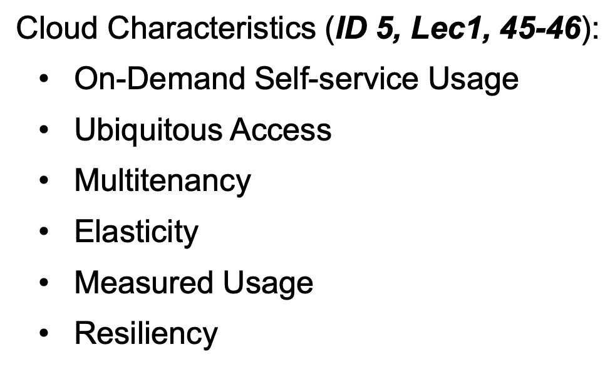 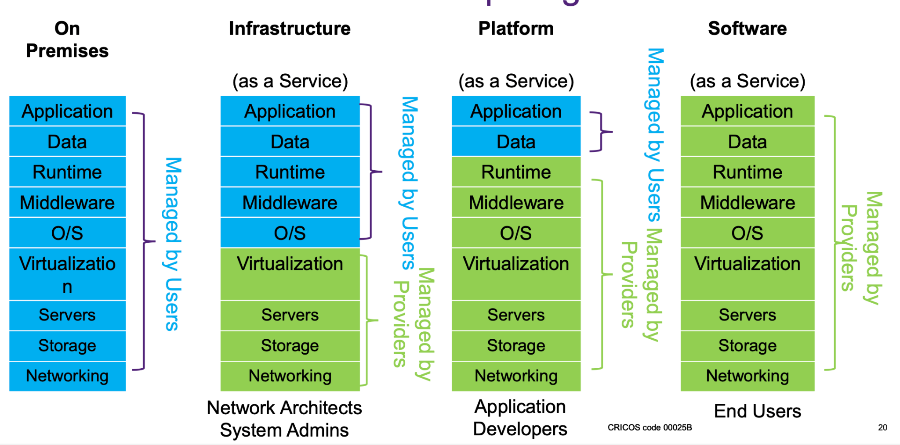vv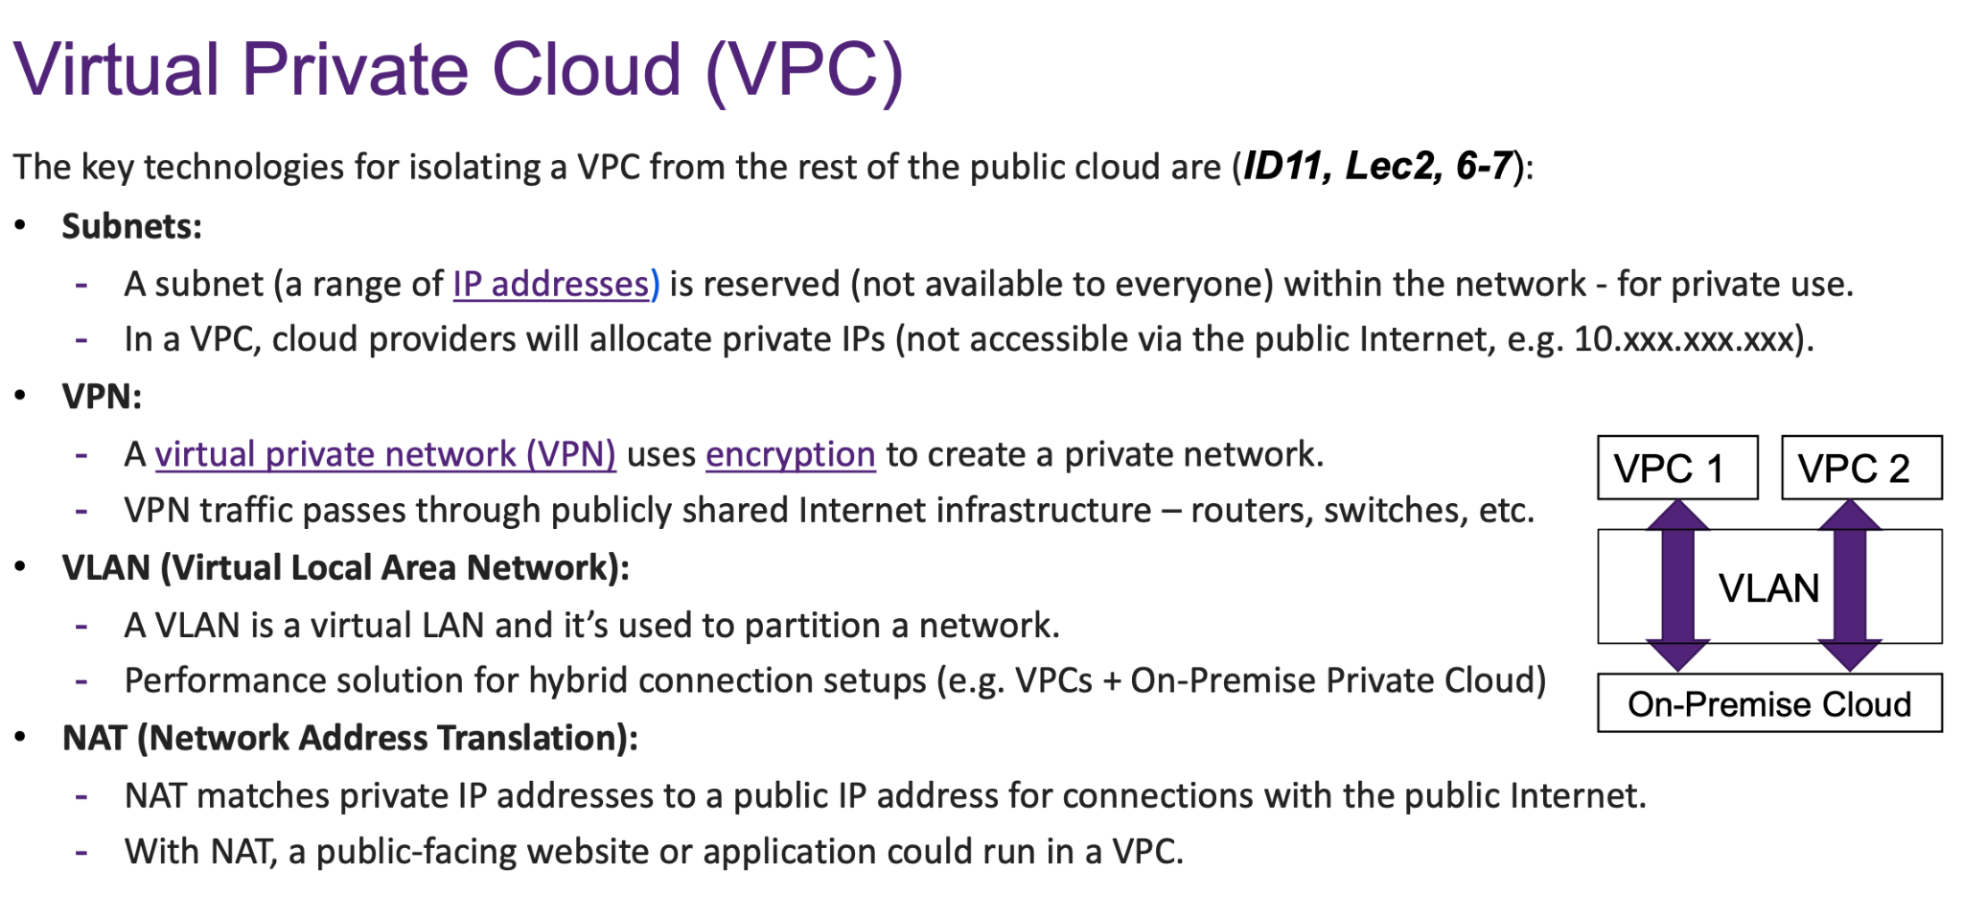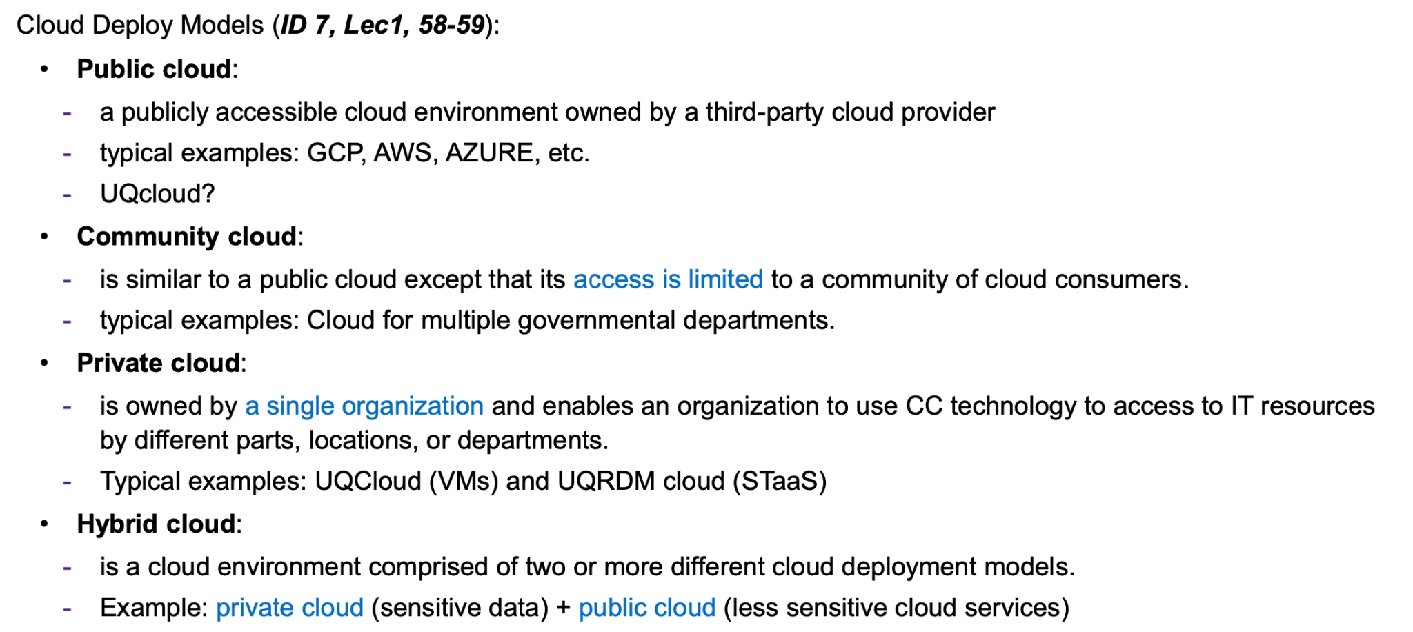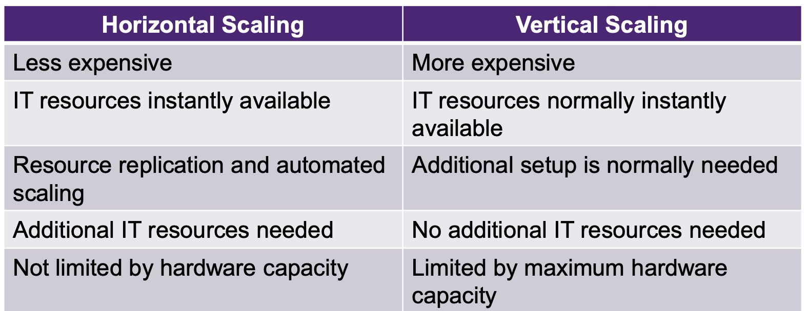
Docker images are objects that contain an OS file system and one or more applications. It is a readable template that can only be used to create and build a container.

Docker containers are running instances of docker images. We are able to run multiple containers from one image, similar to building multiple houses from one blueprint.

Docker registries are where Docker images are stored. There are two types of registries: public and private. Docker Hub is an example of a public registry. Users can upload and download images to/from these registries.

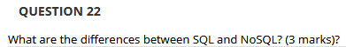
SQL is a structured RDBMS language that has a predefined schema. SQL databases are table and row-based, are vertically scalable, have better support and can support multi-row transactions better than NoSQL.

NoSQL does not use SQL as a querying language and can support multiple storage types. However, it does not get rid of SQL; it complements it. It is distributed and has a fault-tolerant architecture. NoSQL databases do not have a predefined schema and are horizontally scalable.

Horizontal: Allocating or releasing IT resources of the same type
Vertical: Increase or decrease the capacity of current IT resources (less common)

What are the cloud delivery models and corresponding characteristics? Please give an example for each delivery model.
Infrastructure As A Service: self-contained virtual environment of infrastructure-centric IT resources.
User: system administrator. Example: Google compute Engine, Amazon EC2, Azure.

Platform As A Service: pre-defined ‘ready-to-use’ environment consists of already prepared and configured IT resources.
User: developer. Example: Google app Engine, AWS Elastic Beanstalk.

Software As A Service: a shared cloud service and made available as a product.
User: end-user. Example: Google Ecosystem, Microsoft Office.

Compare similarities and dissimilarities between the container and virtual machine technologies.
Containers are cheaper, more efficient, use less memory, are resilient, can be replicated more easily and hundreds more containers can run on a device than a VM.

A virtual machine uses more storage and memory, cannot be replicated easily, is usually less efficient and you are only able to run a very small number of VMs on one machine at a time.
[“/
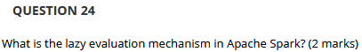
Spark will not begin to execute until it sees an action, such that when a transformation on an RDD is called, the operation is not immediately performed.

Please briefly describe how Spark works?
- Create an RDD object
- SparkContext calculating the dependencies between RDDs and building DAGs
- DAG Scheduler decomposing the DAG graph into multiple stages, each stage containing multiple tasks
- Task scheduler launches tasks to distribute across the worker nodes via cluster manager
- The task scheduler does not know about dependencies among stages.

1. ClusterIP: Default service type for exposing a service within the cluster only.
2. NodePort: Exposes a service on a static port on each node, allowing external access via any node's IP.
3. LoadBalancer: Uses cloud provider load balancer to distribute traffic for high availability and scalability.
4. ExternalName: Maps a Kubernetes service to an external DNS name, often for services outside the cluster.f
Compare RDD with DataFrame?
RDDs are immutable distributed collections of data, partitioned across the nodes in clusters and can be operated in parallel with a low-level API that offers operations (i.e. transformations and actions).
DataFrames are immutable distributed collections of data. But it is organized into named columns, like tables in relational databases.
DataFrame is designed to make processing large datasets even easier than RDDs (a better version than RDD).
No-structured data manipulation (RDD) vs Large structured data query (DataFrame).


- Client asks master which chunk server holds current lease of chunk and locations of other replicas
- Master replies with identity of primary and location of secondary replicas
- Client pushes data to all replicas
- Once all replicas have acknowledged receiving the data, client sends write request to primary
- Primary forwards write request to all secondary replicas
- Secondary replicas reply to primary
- Primary replies to client with success or error message

Describe each step in the READ operation in Google File System (GFS). (5 marks)
- When an application is reading a file, the app needs to go to the GFS client server, the client then sends the file name and chunk index to the GFS master. e.g.The app wants to read the 5th chunk of a particular file.
- After receiving the request, the GFS master will check its table and return the ID of the chunk and all chunk server IP addresses where that chunk has replicas.
- The GFS client can then directly go to the closest chunk server and read data.
- The GFS client doesn’t directly read the data from the master. It only reads a metadata and the actual reading and writing is done between GFS client and chunk server.
- To further reduce the GFS master load, the GFS client cache the chunk operation and chunk location.
(Guaranteed that there is NO GFS read and write in 2023 semester 2, via week13 recording)
So.. would there be write in 2024?
On ed tutor said yes:(
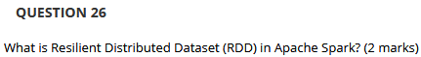
RDD is a fundamental data structure of Spark.
It is an immutable read-only distributed collection of objects and elements.
It supports transformations (which return a new RDD), and actions (which evaluate transformations).
Key-value stores: Key is a string while value can be in different types
E.g: Redis, Riak, Memcached, etc.

Document stores - Similar to key-value stores, but value is a document (nested values)
E.g: MongoDB, CouchDB, etc.

Wide-Column (Column-Family) stores - A column family is a collection of rows and columns, where each row has a unique key and each column has a name, value, and timestamp.
E.g: Hbase, Cassandra, BigTable, etc.

Graph databases - Nodes and relationships (edges) are the bases of graph databases.
E.g: Neo4j, OrientDB, InfoGrid, etc.

What are CAP theorems and BASE properties?
The CAP theorem states that it is impossible for a distributed data store to provide more than 2 out of the following guarantees simultaneously:
- Consistency: Every read receives the most recent write or error.
- Availability: Every request receives a (non-error) response, without the guarantee of the most recent.
- Partition tolerance: The system continues to operate despite some of the messages being dropped or delayed by the network between nodes.

BASE in Nosql: The opposite of ACID for transactions in a relational database
- Basically Available: one distributed system has a failure part but the total system working properly.
- Soft-state: corresponding to the hard state, which guarantees consistency and durability, and allows delays and outages (in short periods).
- Eventually-consistent : strong-consistency means every transaction needs to be consistent, but in a distributed system, it is enough to eventually be in a consistent state.

What are the implementation options of NoSQL databases?
Cassandra - AP
HBase - CP
MongoDB - CP
Redis - CP

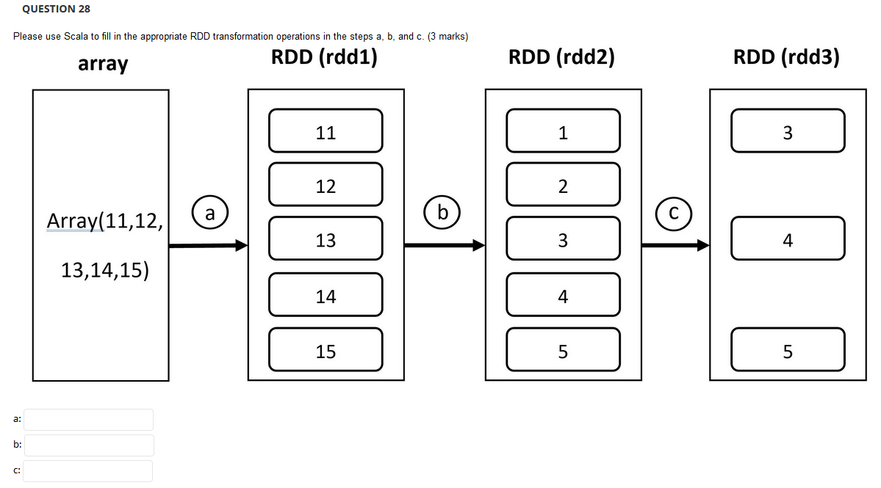
a: val rdd1 = sc.parallelize(array)
b: val rdd2 = rdd1.map(x => x-10)
c: val rdd3 = rdd2.filter(x => x > 2)
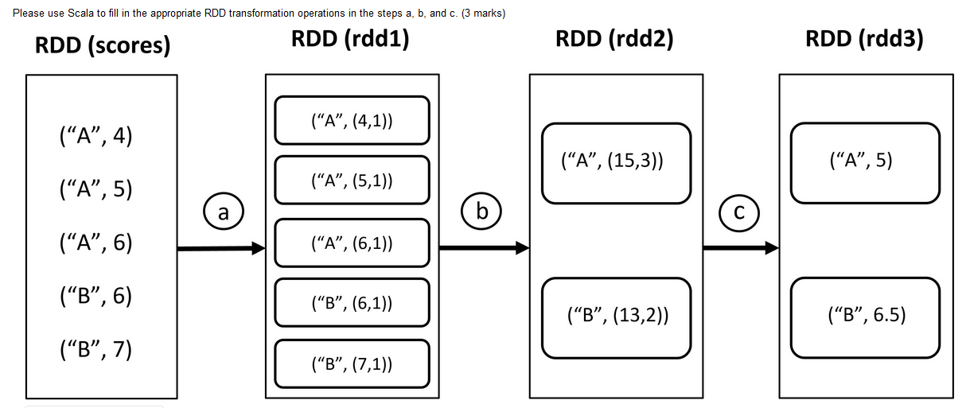
a: val rdd1 = scores.mapValues(x => (x,1))
b: val rdd2 = rdd1.reduceByKey((x, y) => (x._1 + y._1, x._2 + y._2))
c: val rdd3 = rdd2.mapValues(x => x._1/x._2)

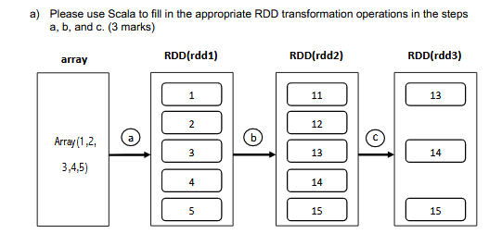
A: val rdd1 =sc.parallelize(array)
B: val rdd2 = rdd1.map(x => x+10)
C: val rdd3 = rdd2.filter(x=> x>12)

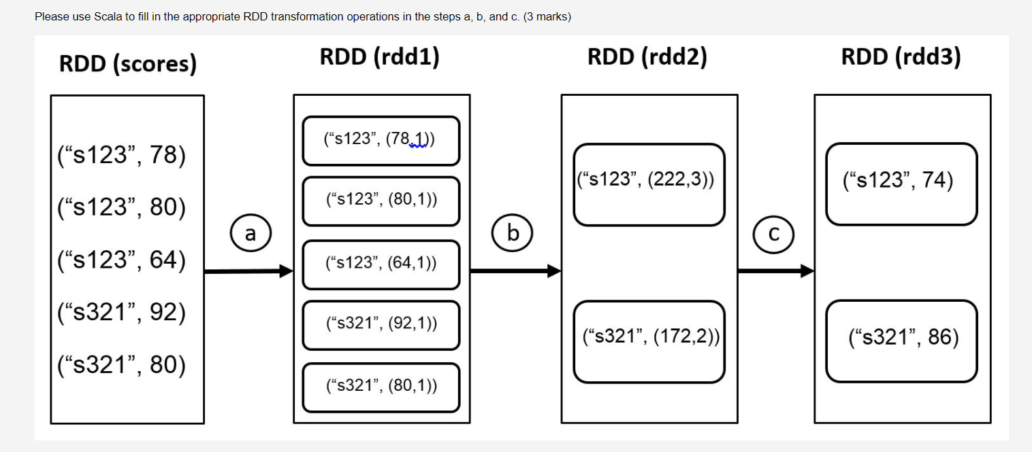
A: val rdd1 = scores.mapValues(x => (x,1))
B: val rdd2 = rdd1.reduceByKey((x,y) => (x._1+y._1,x._2+y._2))
C: val rdd3 = rdd2.mapValues(x=> x._1/x._2)
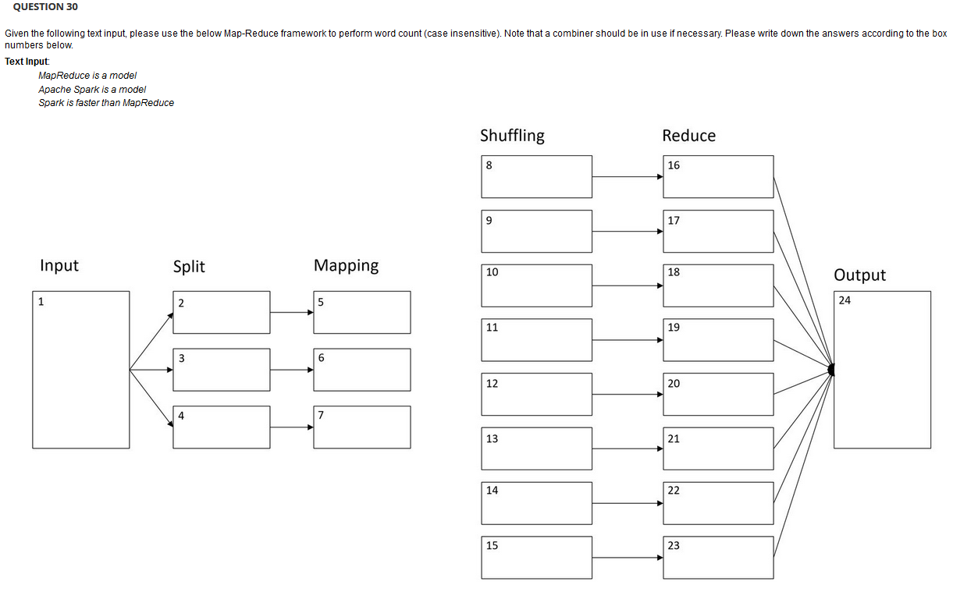

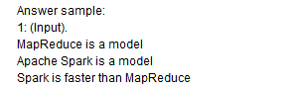
Note: Case insensitive so can just write as lowercase
Split
- MapReduce is a model
- Apache Spark is a model
- Spark is faster than MapReduce

Mapping
- (MapReduce, 1), (is, 1), (a, 1), (model, 1)
- (Apache, 1), (Spark, 1), (is, 1), (a, 1), (model, 1)
- (Spark, 1), (is, 1), (faster, 1), (than, 1), (MapReduce, 1)

Shuffling
- (MapReduce, (1, 1))
- (is, (1, 1, 1))
- (a, (1, 1))
- (model, (1, 1))
- (Apache, 1)
- (Spark, (1, 1))
- (faster, 1)
- (than, 1)

Reduce
- (MapReduce, 2)
- (is, 3)
- (a, 2)
- (model, 2)
- (Apache, 1)
- (Spark, 2)
- (faster, 1)
- (than, 1)

Output
(MapReduce, 2), (is, 3), (a, 2), (model, 2), (Apache, 1), (Spark, 2), (faster, 1), (than, 1)

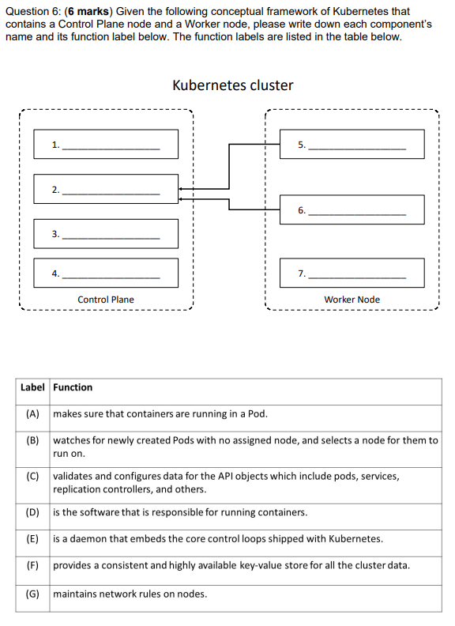
- Kube-Controller-Manager, E
- Kube-API Server, C
- Kube-scheduler, B
- Etcd, F
- Kubelet, A
- Kube-proxy, G
- Container runtime, D

Please briefly describe how a digital works when sending a message from a sender to a receiver.
- The sender selects the file to be digitally signed in the document platform or application and calculates the unique hash value of the file content (1- hashing).
- This hashed value is encrypted with the sender’s private key (2- encrypt with private key) to create the digital signature
- The digital signature is appended to the plain text message (3- append).
- The receiver use the same hash function to calculates the hash value of the plain text messages (4- hashing)
- The receiver decrypts the digita l signature with sender’s public key (5- decrypt with public key).
- The receiver compares the hash value of the plain text in Step 4 and the decrypted digital signature in Step 5 (6- Compare).

Digital Signature Process:
1.The sender selects the file to be digitally signed in the document platform or application and calculates the unique hash value of the file content (1-hashing).
2.This hashed value is encrypted with the sender’s private key (2- encrypt with private key) to create the digital signature
3.The digital signature is appended to the plain text message (3-append).
4.The receiver use the same hash function to calculates the hash value of the plain text messages (4-
hashing)
5.The receiver decrypt the digital signature with sender’s public key (5- decrypt with public key).
6.The receiver compares the hash value of the plain text in Step 4 and the decrypted digital signature in Step 5 (6-Compare).

Possibility Questions
From the topic lists given by course, this section is a collection of some topics that may appear on the exam

Encryption
- Synchronous
  - Symmetric encryption uses the same key for both encryption and decryption, both of which are performed by authorized parties that use the one shared key.
  - Parties that rightfully decrypt the data are provided with evidence that the original encryption was performed by parties that rightfully possess the key.
  - A basic authentication check is always performed.
  - Typical algorithms: DES, AES, RC4/RC5, etc.
  - Diagram: 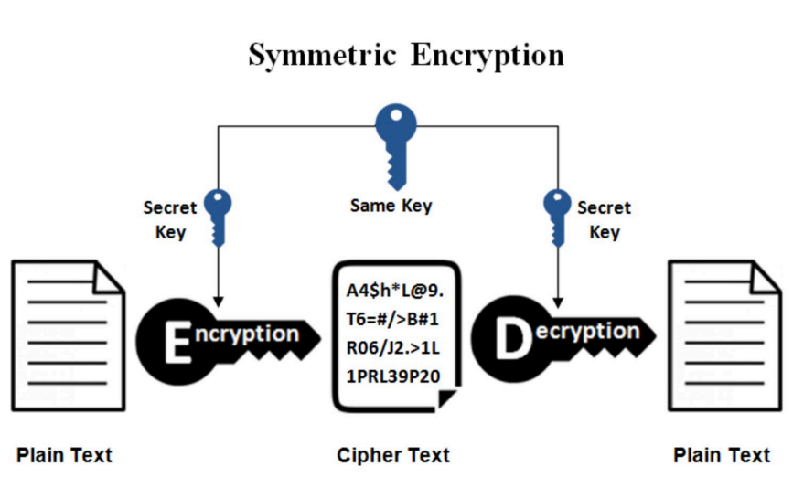
- Asynchronous
  - Asymmetric encryption relies on the use of two different keys, namely a private key and a public key.
  - The private key is known only to its owner
  - The public key is commonly available.
  - A document that was encrypted with a public key can only be correctly decrypted with the corresponding private key.
  - Asymmetric encryption is almost always computationally slower than symmetric encryption.
  - Typical algorithms: RSA and etc.
  - Diagram: 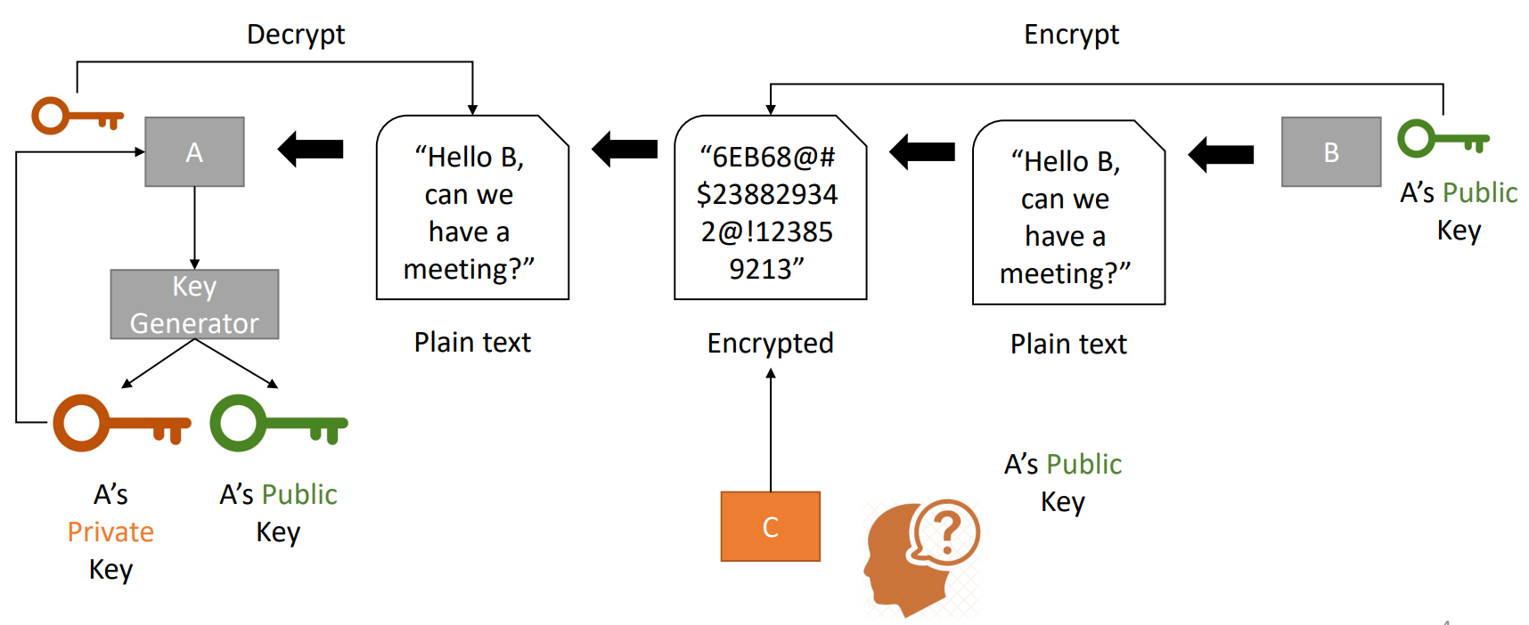

Hive:
- HiveQL does not strictly follow the full SQL-92 standard but offers some extensions not found in SQL, such as multitable inserts.
- HiveQL has full ACID properties.
- Hive is a data warehouse that is good for OLAP rather than OLTP
- Data in Hive is organised in
  - Tables
    - - Analogous to relational tables
    - - Each table has a corresponding directory in HDFS
    - - Data serialized and stored as files within that directory
  - Partitions
    - - Each table can be broken into partitions
    - - Partitions determine distribution of data within subdirectories
  - Buckets
    - - Data in each partition divided into buckets
    - - Based on a hash function of the column
    - - Each bucket is stored as a file in partition directory
Apache Pig
- high-level platform for creating programs that run on Apache Hadoop
- can execute its Hadoop jobs in MapReduce or Apache Spark
- Language used is called Pig Latin
- user can write in Java, Python, JavaScript, etc and then call directly from the language
- Limitations: No loops and conditions

Differences between Hive and Pig
- Hive is declarative and pig is procedural
- Pig is more suited for adhoc analysis whereas Hive is a reporting tool
- Pig is used by researchers and programmers, whereas Hive is used by business analysts

DFS
- Characteristics
  - Access transparency
  - Location transparency
  - Concurrency transparency
  - Failure transparency
  - Replication transparency
  - Migration transparency
  - Heterogeneity
  - Scalability

Sun NFS
- a client-server application, where a user can view, store and update the files on a remote computer
- designed to be independent of computer, operating system, network architecture, and transport protocol
- allows the user or system administrator to mount complete or a partial file system on a server

1 hr to exam now, good luck everyone

